***12. What are Release Pipelines and resources in Azure***

If release pipeline is not visible, follow this solution [Release pipelines not visible on Azure DevOps page - Stack Overflow](https://stackoverflow.com/questions/66802191/release-pipelines-not-visible-on-azure-devops-page)

* Go to releases under pipeline section -> Click on new pipeline.
* Now rather than deploying it in our hosted servers, azure itself provides us the platform for hosted servers.

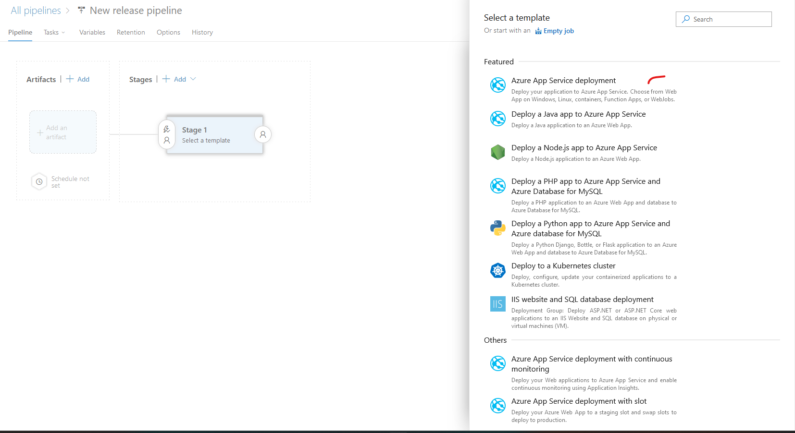

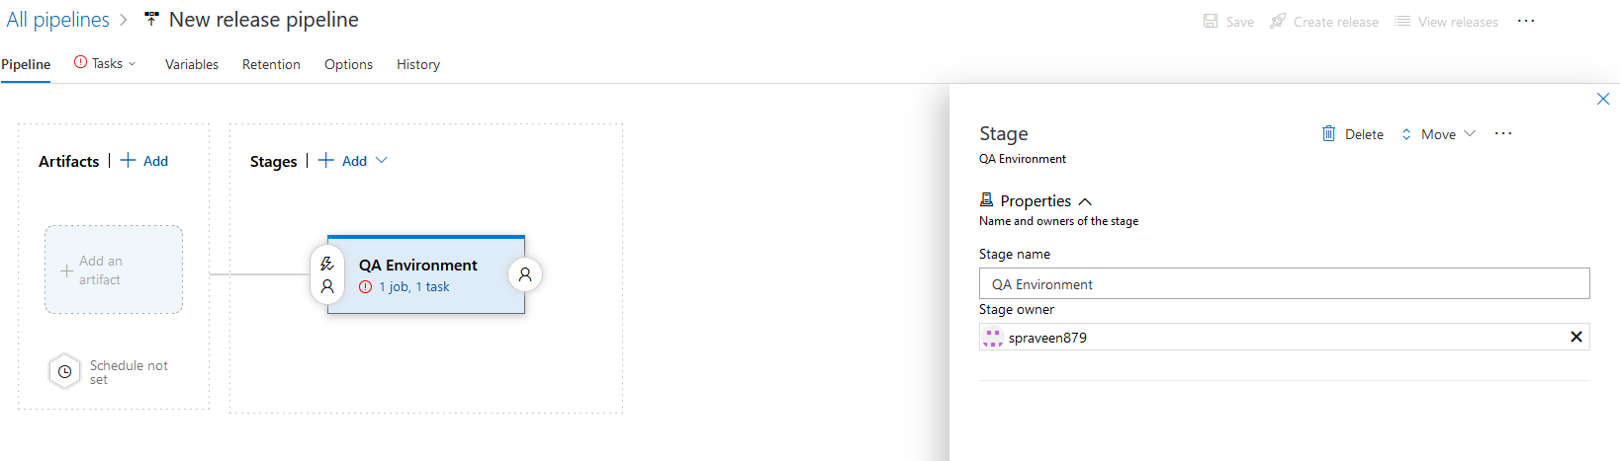

* Assume that we are deploying the code in qa environment hence the name.
* Click on 1 job, 1 task.

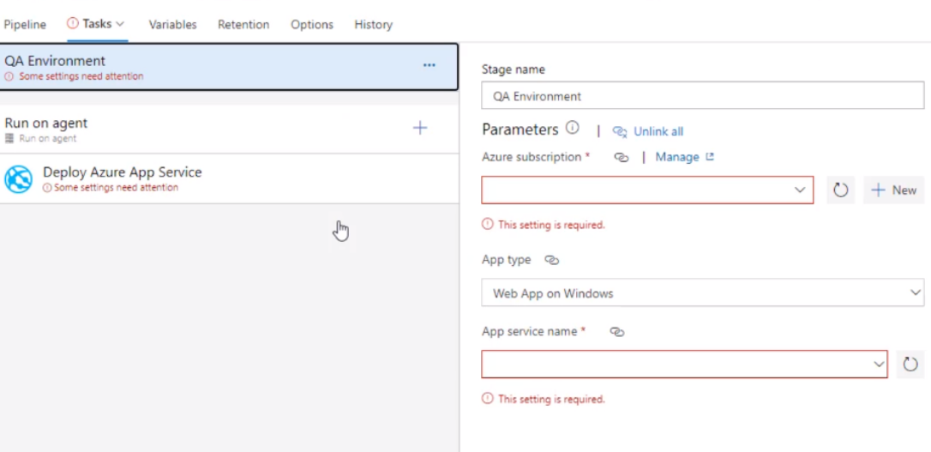

* We have 30 days free trial so we can use for getting azure cloud by giving credit card details.
* Taking ss from here.
* From this page, we are moving to portal.azure.com to create a subscription and linux machine which are required to fill these details

***13. Creating resources for environments from Azure Portal***

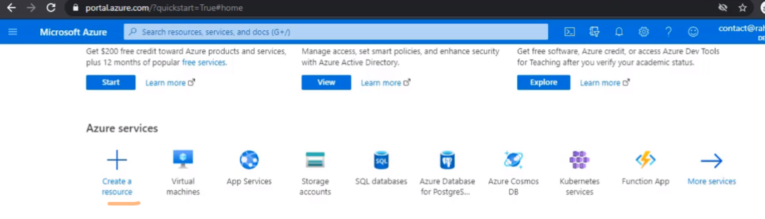

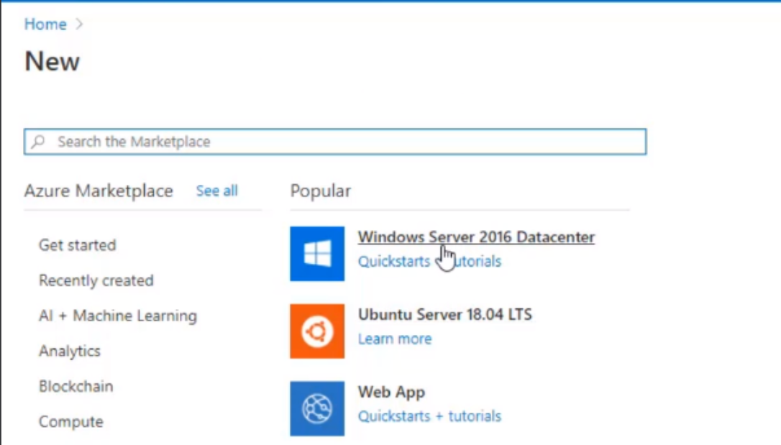

Click on create a resource and webapp. Web app is something like an inbuilt hosted server. If you select windows or ubuntu, in that machine you need to install tomcat and then paste the war file.

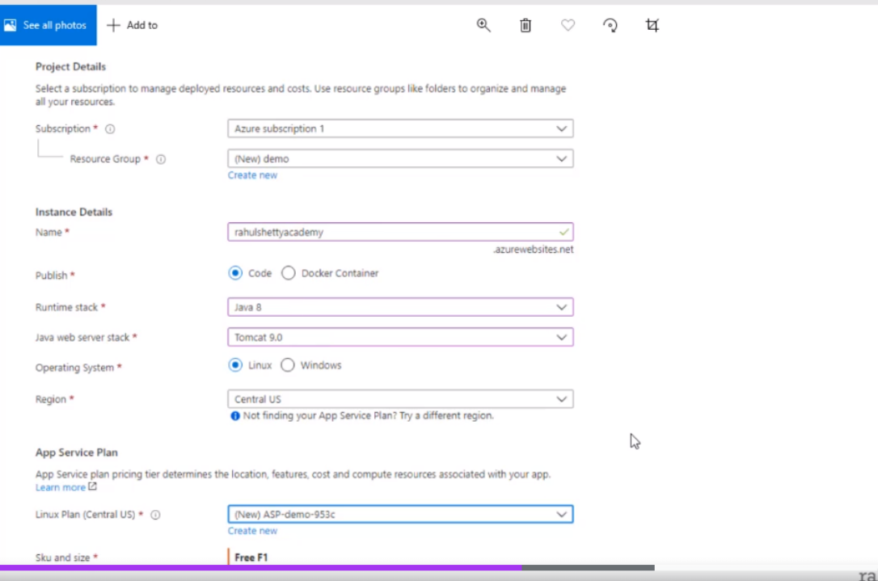

* Resource group is any name.
* Name – rahulshettyacademy. This will become the url like localhost:8080
* Click on create.
* Review page appears and then click on create

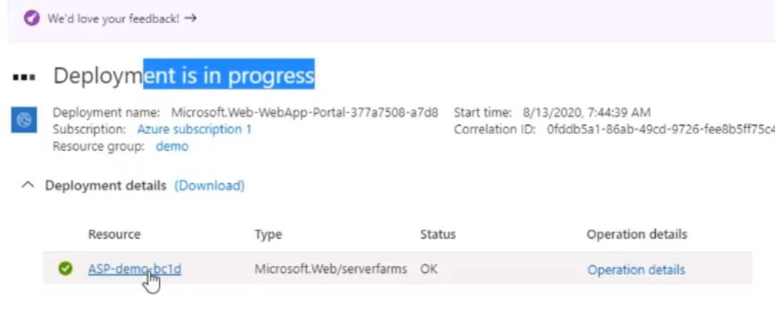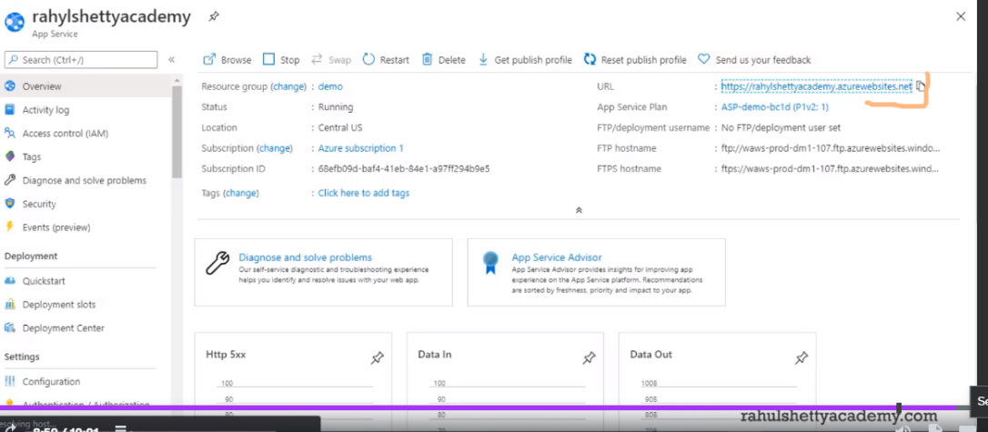

Now the resource is created with the url at the top right. When you open that url, apache tomcat opens

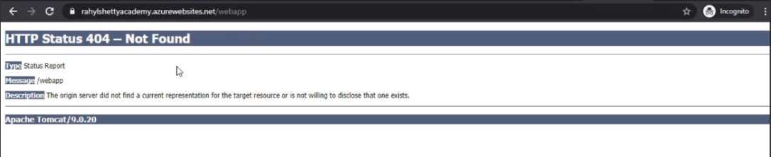

This is the ss before war file is deployed in the url. Once done, you will be able to see the contents in the UI with this URL like how we saw it in apache tomcat

***14. Setup release pipeline with linux resources to deploy the artifact***

Previously we created a azure subscription and had a linux machine ready to deploy the code. Now we are going to deploy the war file in the linux machine created



* Now we are coming back to this page since subscription and linux machines are created.

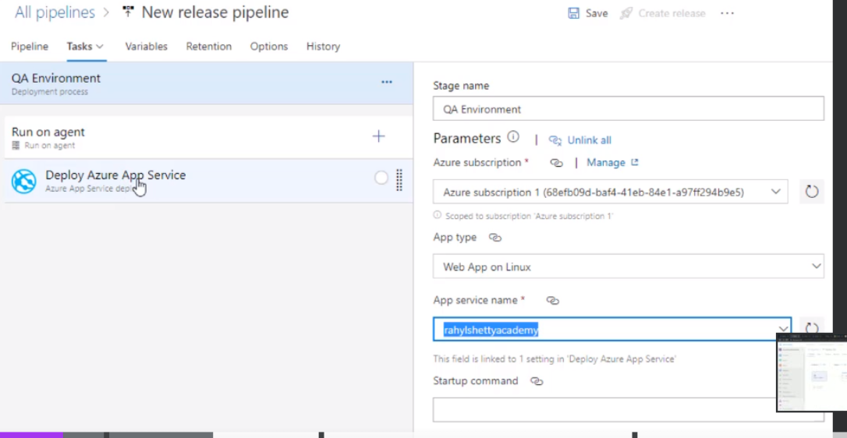

* The dropdowns will be populated since subs is aready created. App type is web app on linux since we have created a linux machine. Drop down for service name will be displayed

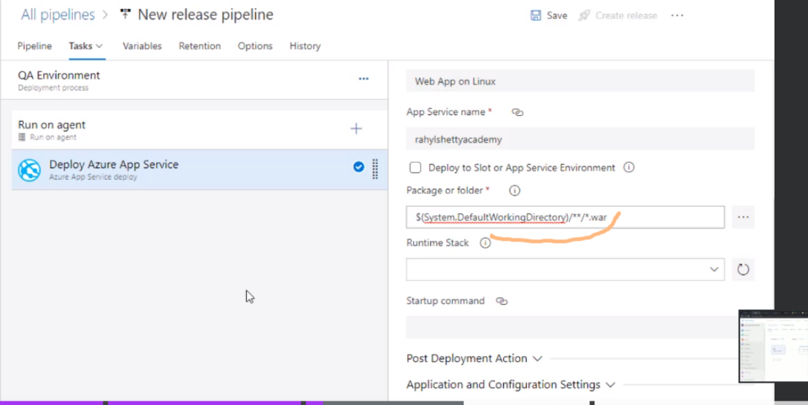

* Here, System.DefaultWorkingDirectory has the war file that we have moved it from agent folder as the artefacts. Basically it is the war file that is published in the build pipeline. Inside that, we are asking to take the .war file
* Now we have the war file, linux machine, tomcat url. So this war file will be deployed inside the linux machine on the tomcat url
* Click on save

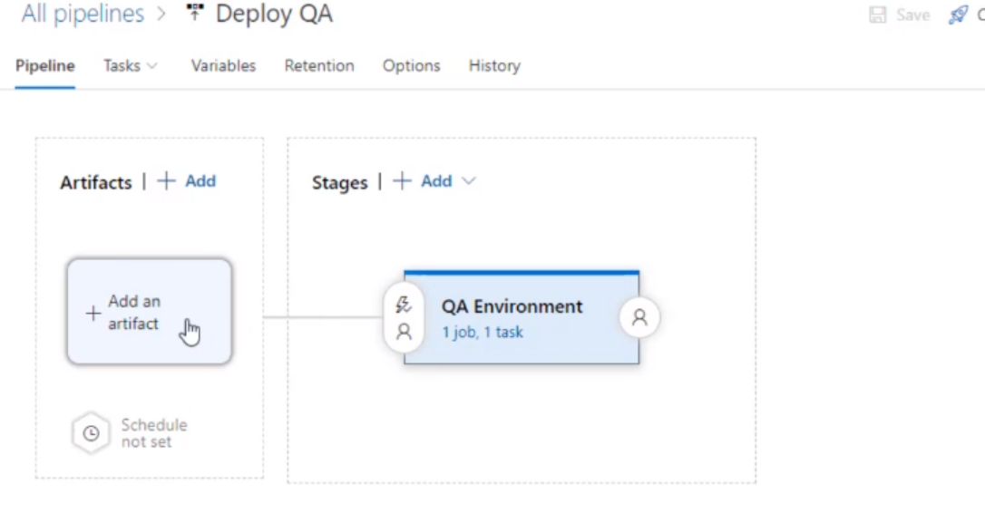

* Now go to pipeline. We previously clicked on 1 job and 1 task (See the top of this doc). We have made all config inside that.
* Click on add artifact. We have the war file

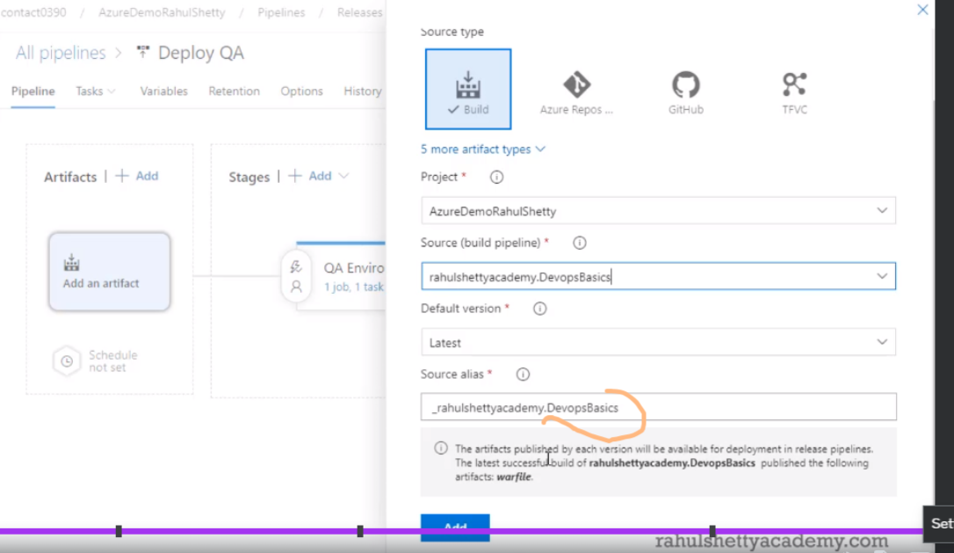

We have only one war file so select that and click on add. Others are populated by default

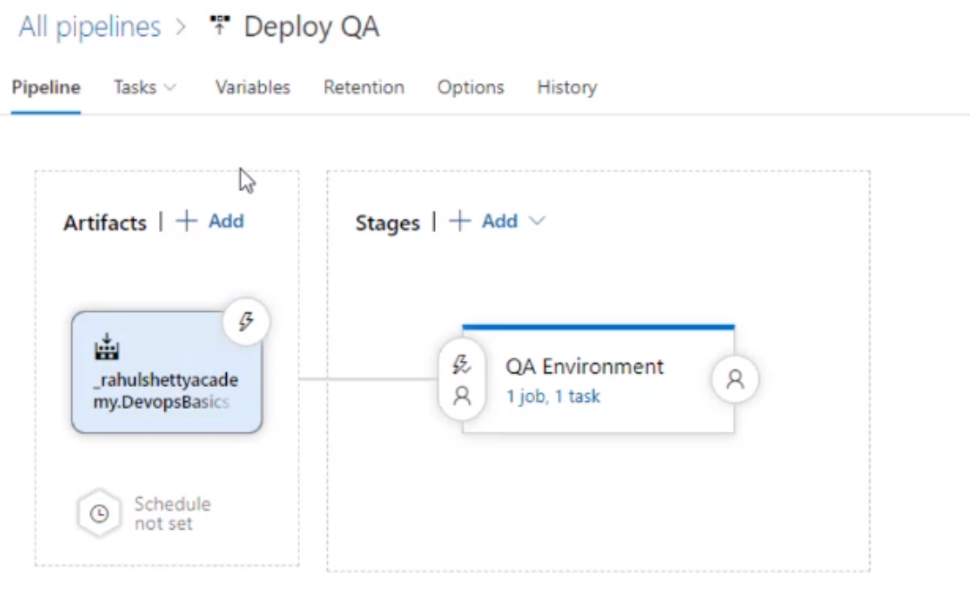

Appears like this now. Click on save

***15. Importance of create release option in azure dev portal***

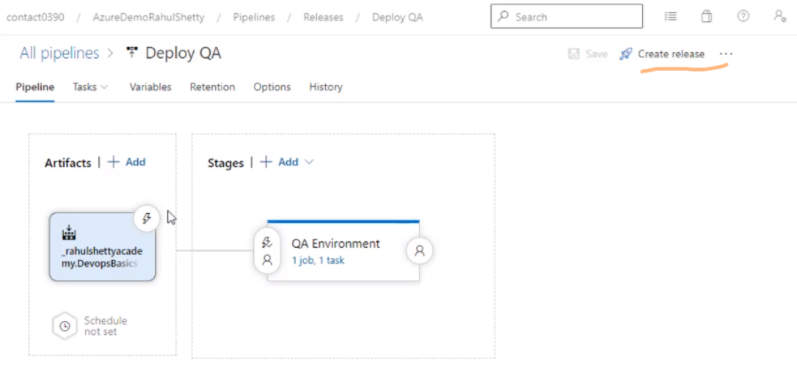

Click on create release and give a description and click on create. The left portion is build pipeline and right portion is release pipeline.

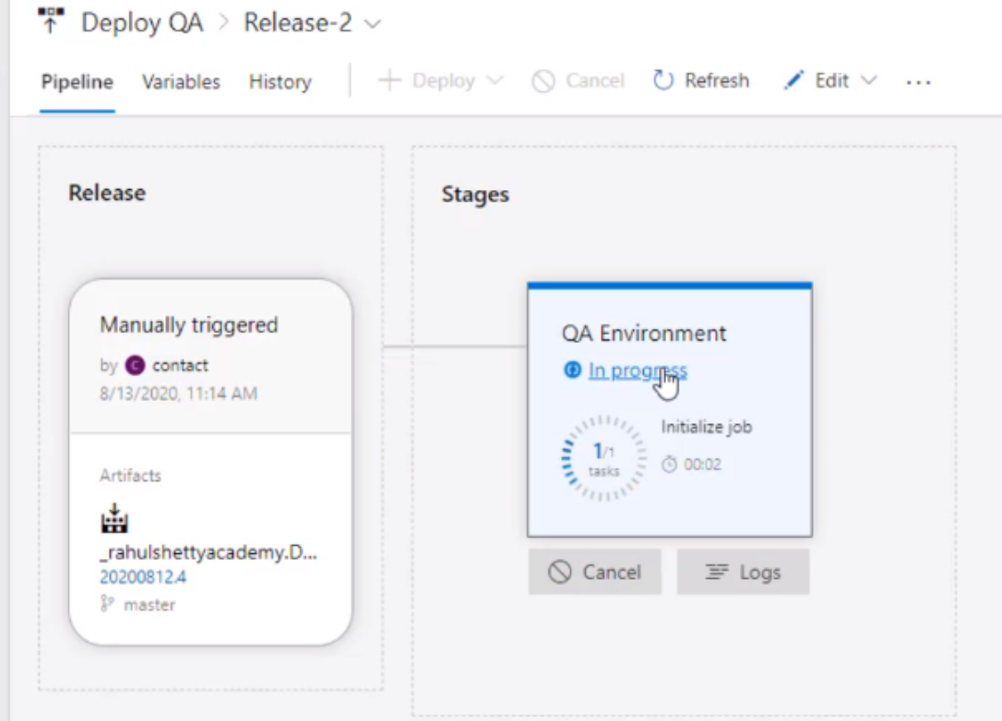

* The pipeline gets the artifact from build pipeline and release pipeline is triggered if you see above.

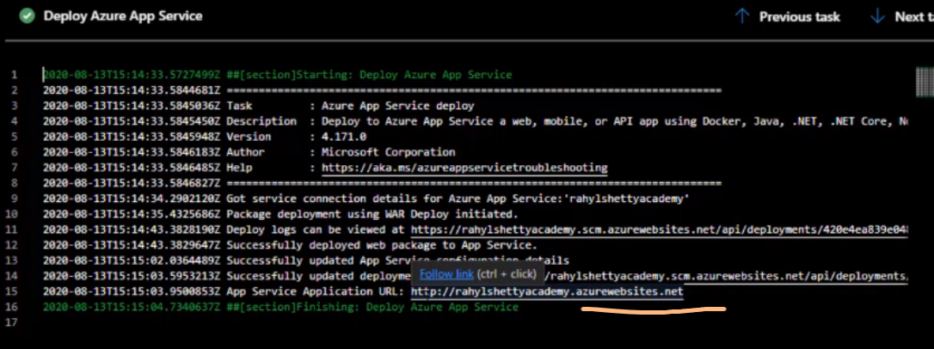

* Now it says the .war file is deployed in this url

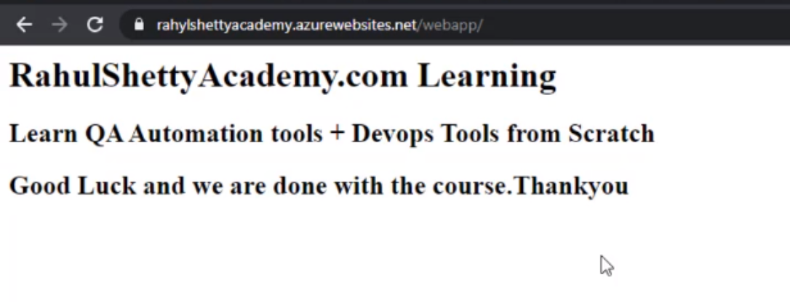

* Now if you refresh, the UI is displayed in the url where there was no content previously.
* Important note : Till now in build pipeline, we have trigger:master in the yaml file. SO whenever a git push is done to master, build pipeline will run. For release pipeline, we have manually created and integrated with build pipeline and deployed war file
* One thing is missing. Whenever a git push is done, in addition to build pipeline, release pipeline should also run.

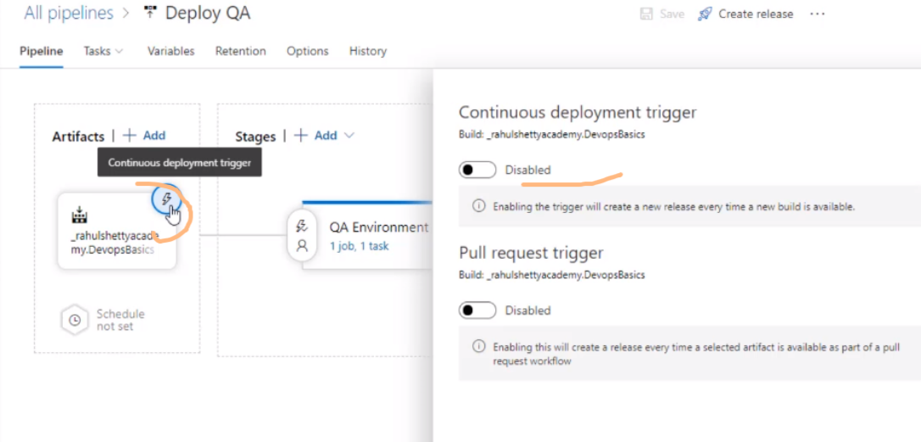

Click on the fire symbol in the build pipeline and enable the first option. Now try changing something in master and see how with new war file generated, even release pipeline will get triggered

***16. Importing Git repository of Automation projects to Azure Repository***

Now our goal is to run set of automation cases so that after the build pipeline is triggered, QA validation starts. For that, click on the repos section

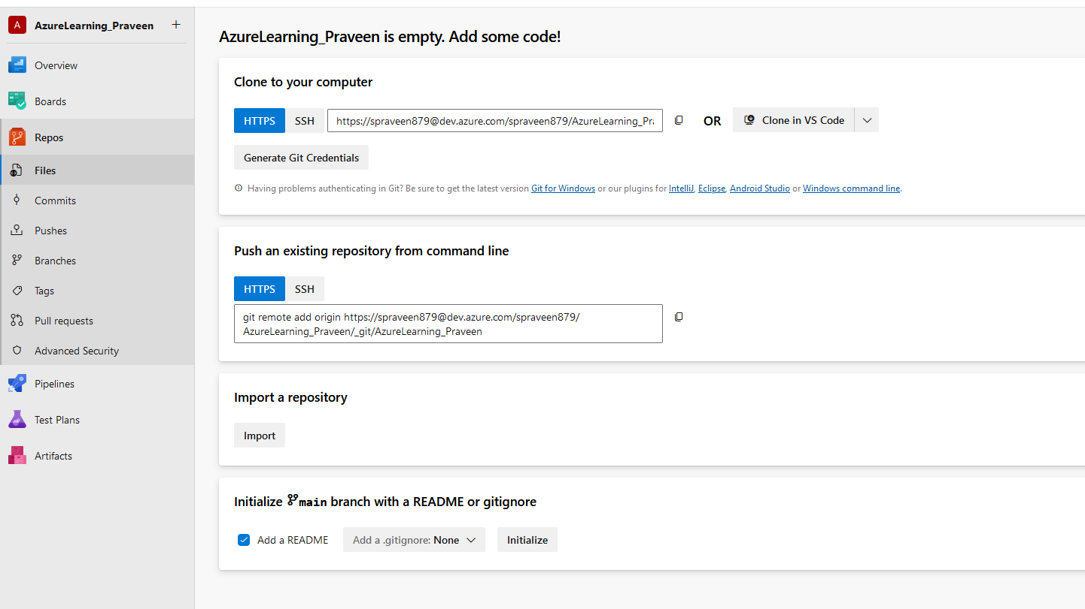

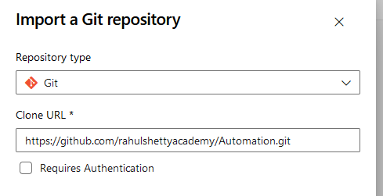

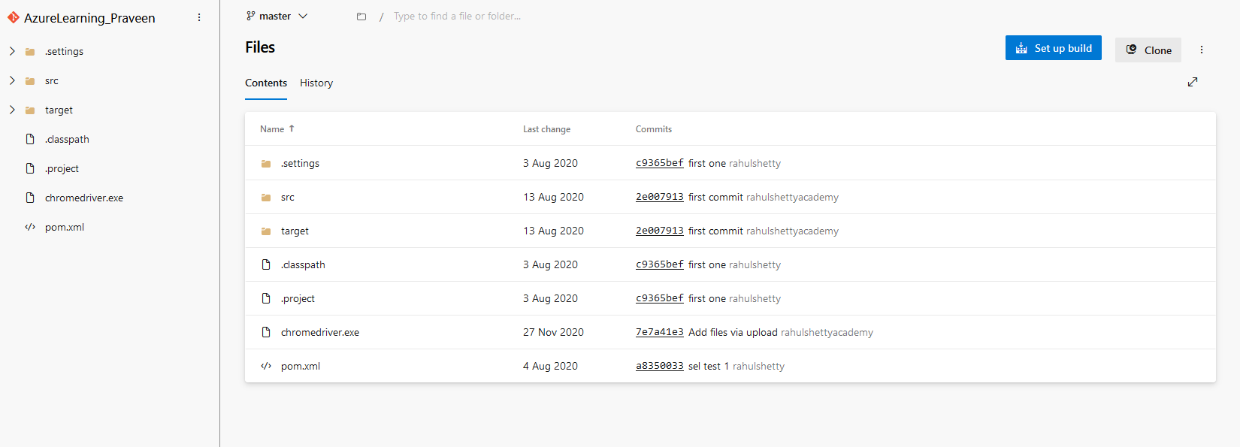

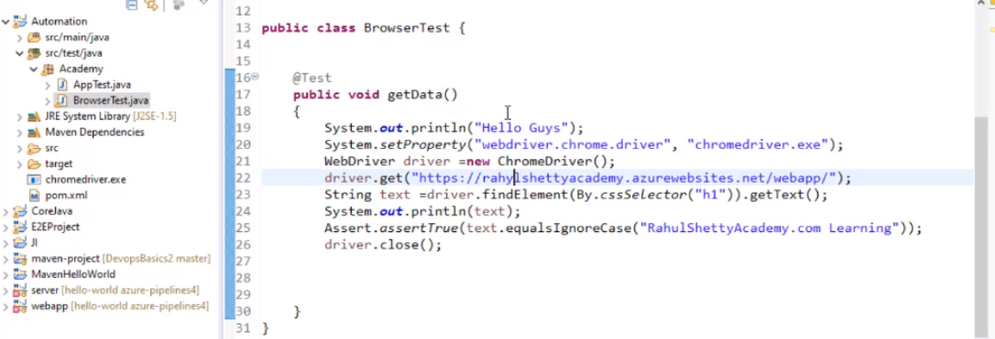

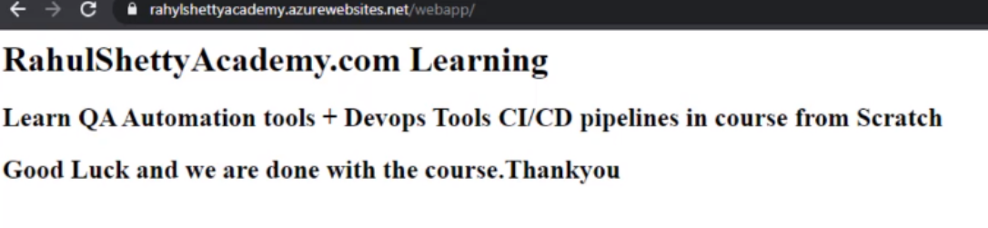

There is this code inside the repo. So when you run this with mvn test, it runs and validates the code the war file deployed on the UI.

***17. Configuration to add tests from azure repositories to release pipelines***

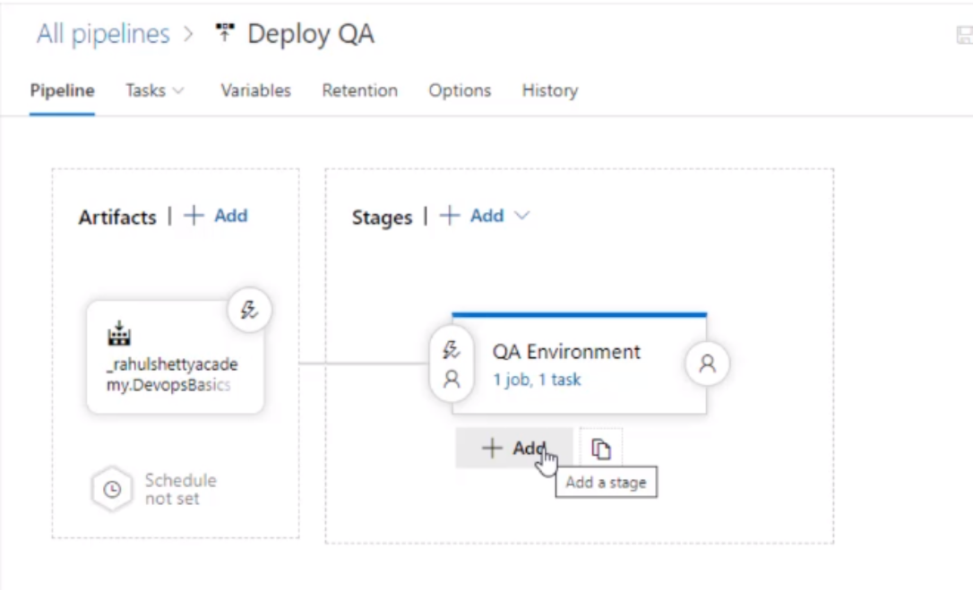

* Click on add a stage.

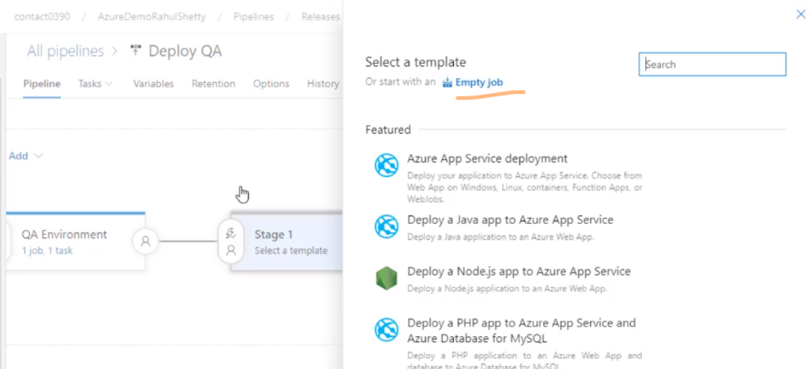

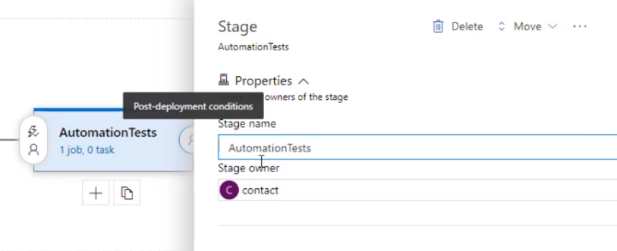

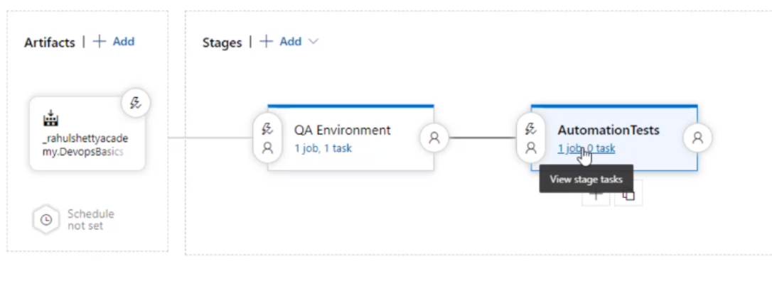

* Now we get war file from build pipeline. From there we are giving the war file to release pipeline which is deployed in linux machine
* Click on add at the top of the build pipeline

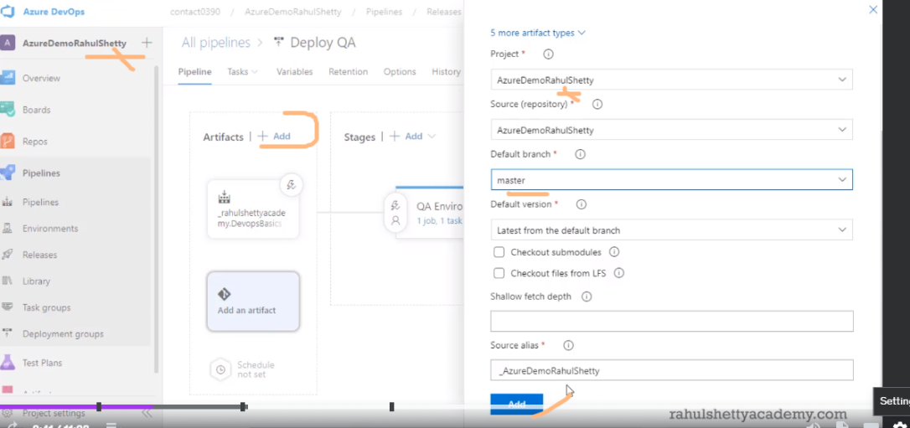

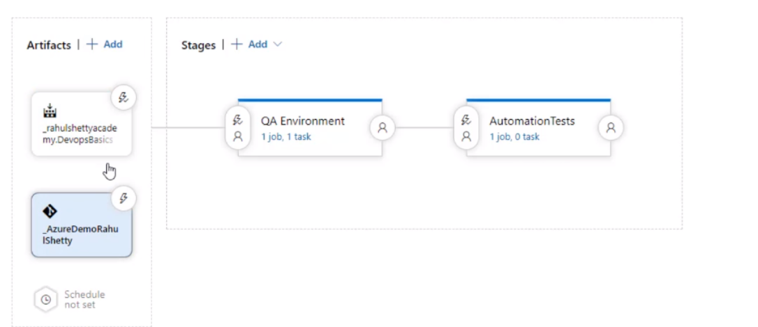

* Now we will configure automation tests and consume war file from another build(Copy of same war file will be created) and then run the automation tests.
* Click on 1 job, 0 task in automation tests.

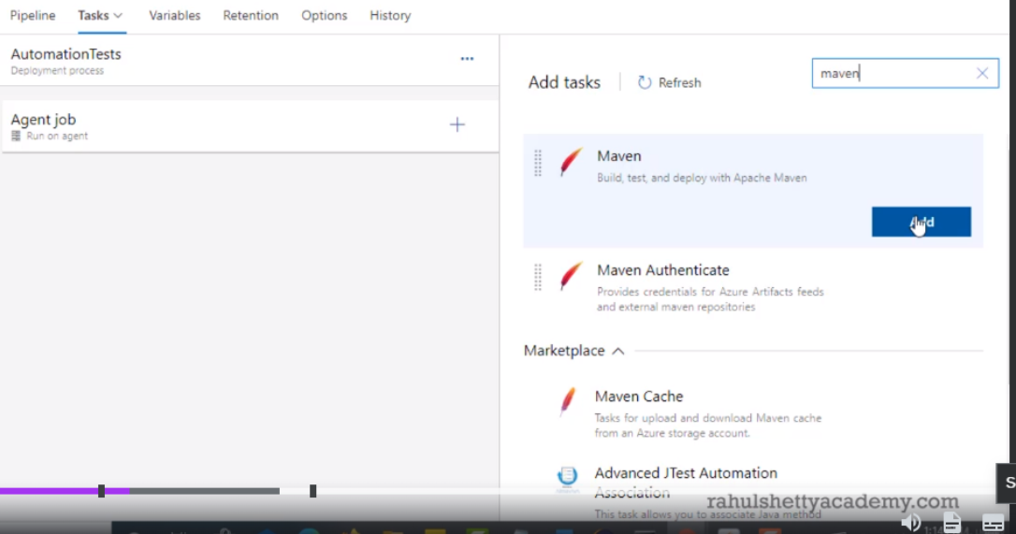

Like how we added webapp, add maven now

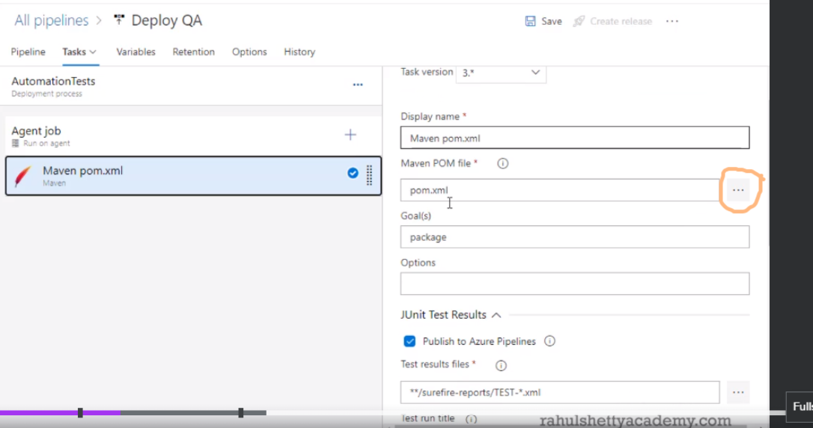

Now we have to give location where pom.xml is located

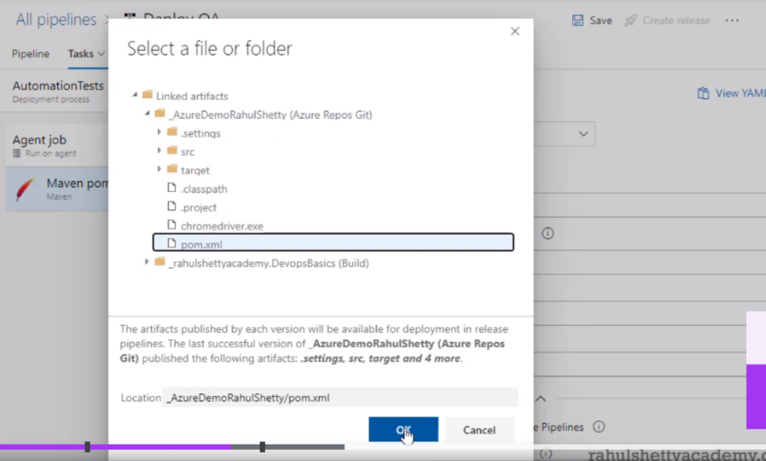

When you click on three dots, we will get the build pipeline artefact and azure repo here. We can select whichever artefact we want. Now our automation code is in code repo, so we are selecting the pom.xml

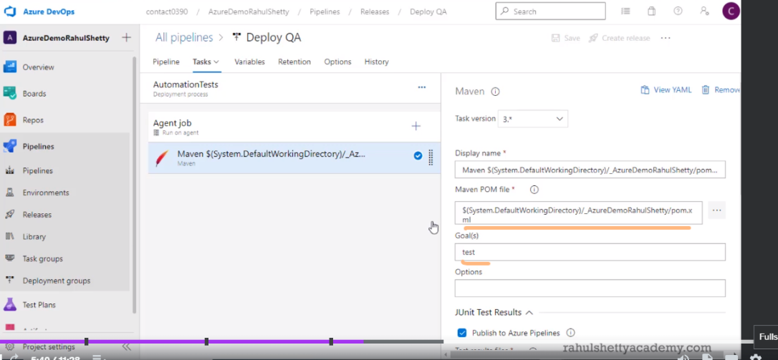

Maven POM file given is the .war file generated from the second build pipeline we just created.

Now after selecting pom.xml, we need to give goal as test so that the automation code will run. Click on save now

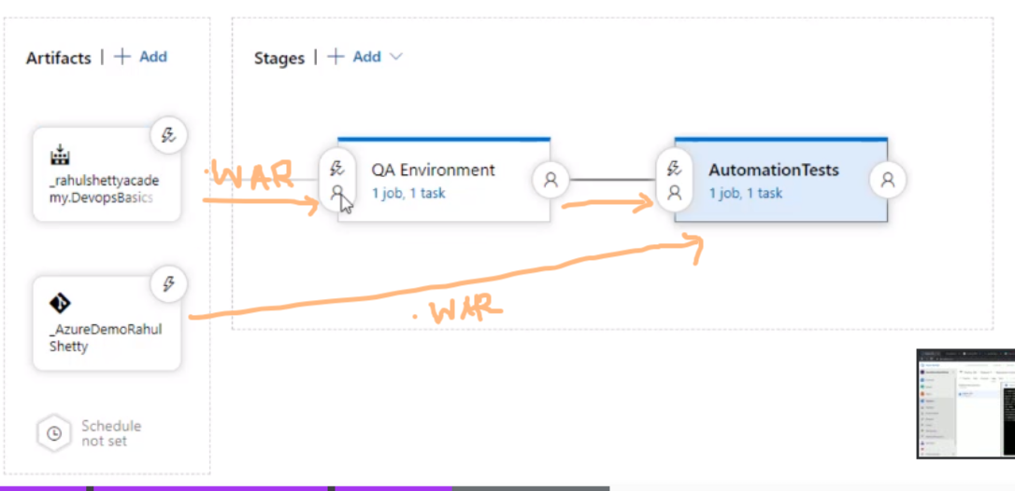

Now the flow is ready.

Process : The QA Environment is the release pipeline which consumes the .war file from build pipeline and deploys the code. The Automation tests will consume .war file from azuredemorahulshetty. Whenever a war file is generated after a git push, automation tests will be run

***18. Pushing the tested code to production after Successful Automation job runs***

Similar to how we created Release pipeline for qa env, create a pipeline for prod environment. For this, create a new resource and select webapp. In details provide OS as linux and URL name as prodrahulshettyacademy. Repeat sections 13 and 14 by just changing instance name

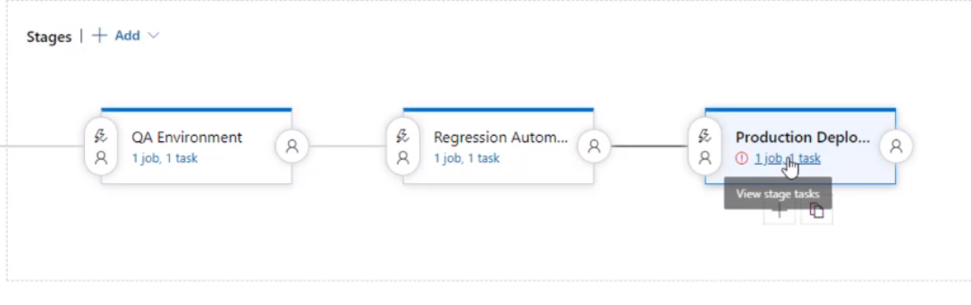

Click on 1 job 1 task

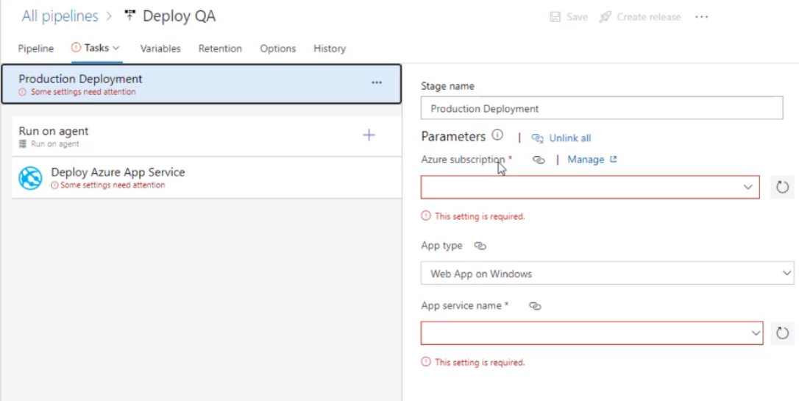

We created only one webapp that was for qa environment. Create a new subs for prod now

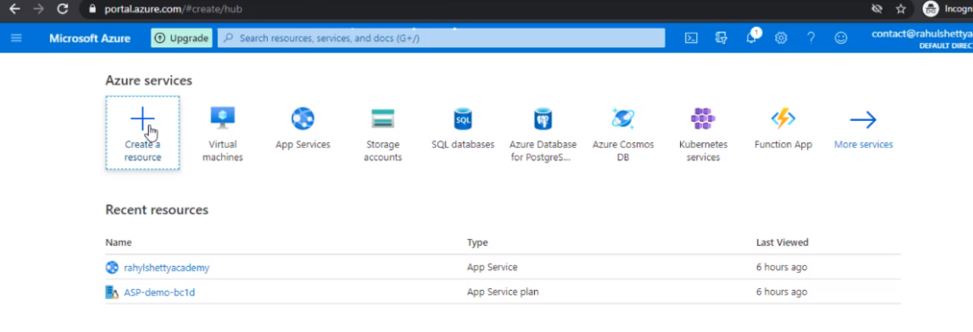

Go to porta.azure.dom for creating a resource

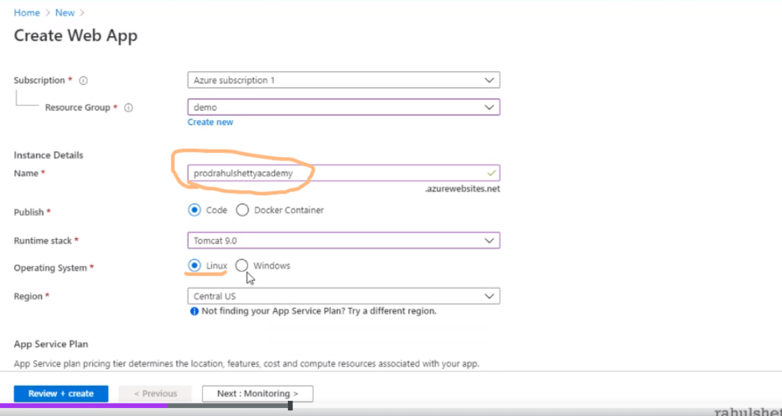

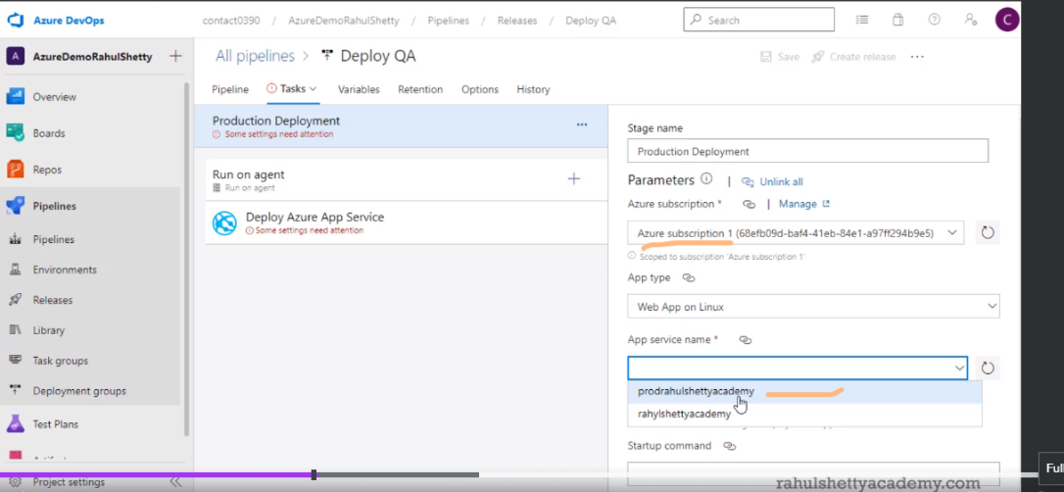

Now this is new subscription created.Instance name is prodrahulshettyacademy.

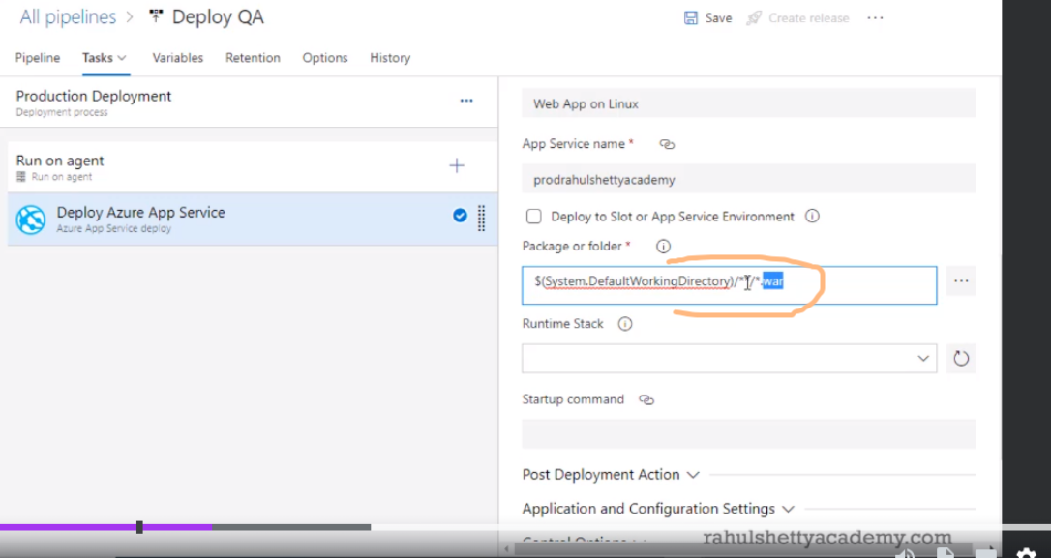

This will pick war file from the build pipeline created

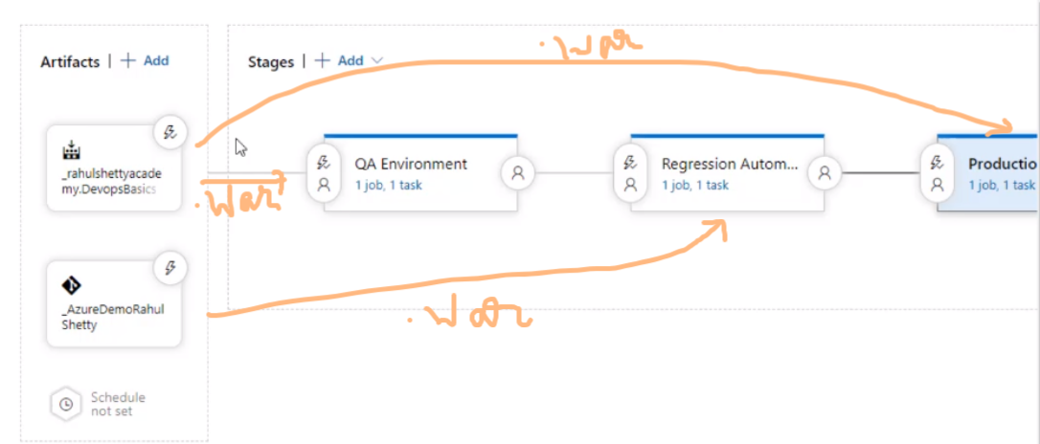

Whenever you make some git push, everything will run based on .war file generated